EXP NO 1: WINDOWS FUNDAMENTALS 1 SOMILA. SA

231901052

DATE: 29/01/2025

AIM:

WINDOWS FUNDAMENTALS 1

To complete and explore the tasks in windows fundamentals 1.

PROCEDURE: Complete the tasks as per the instructions given in the respective tasks.

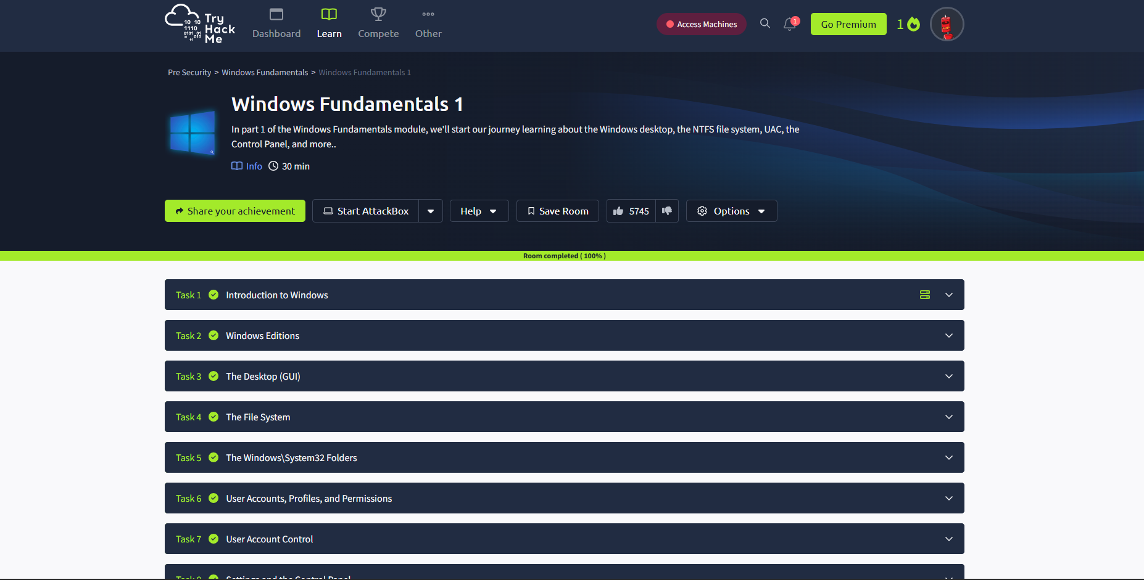

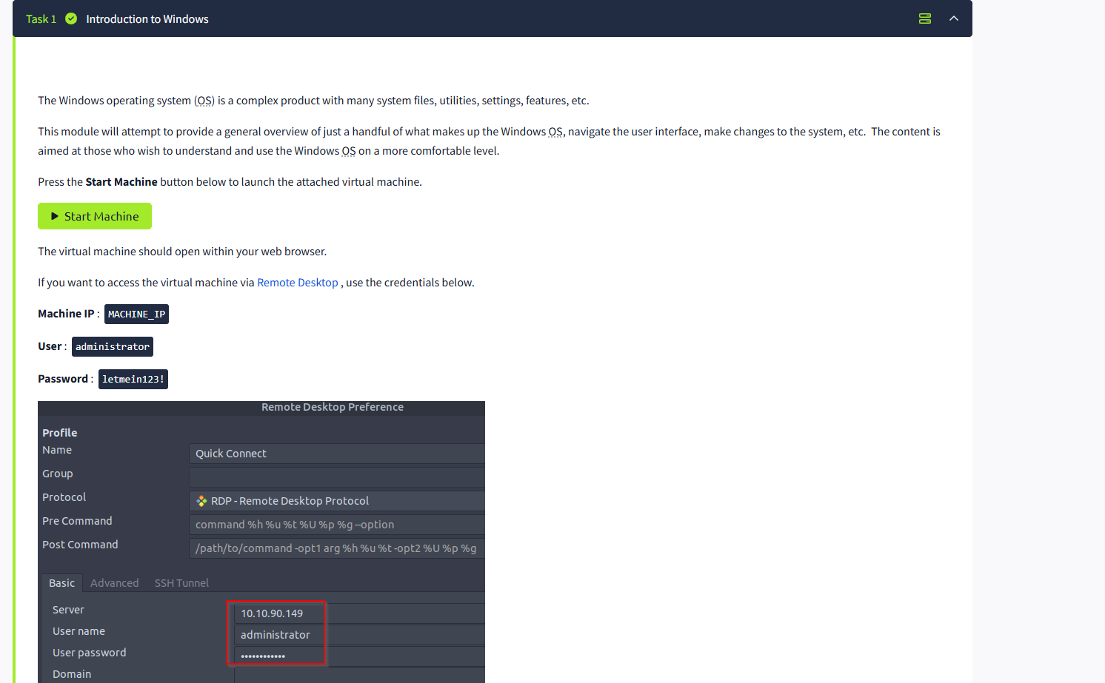

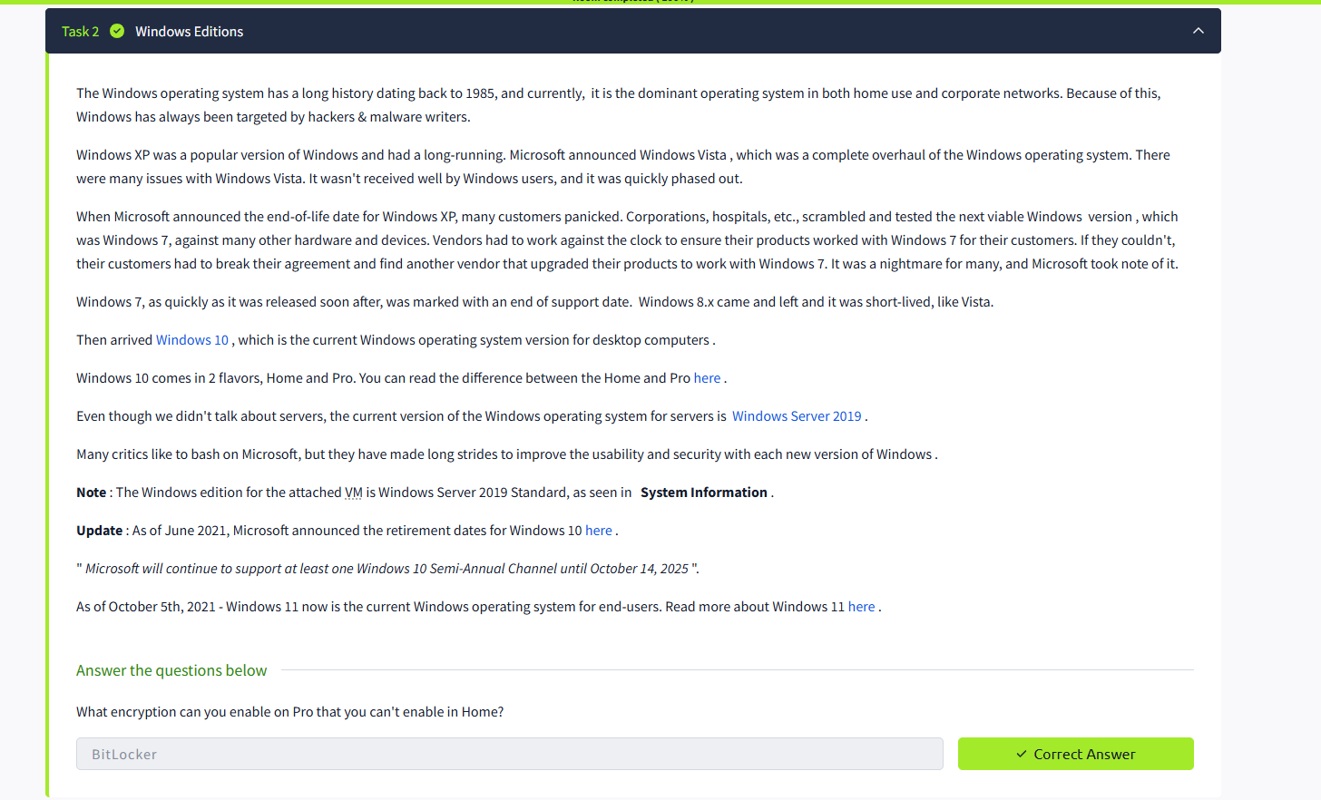

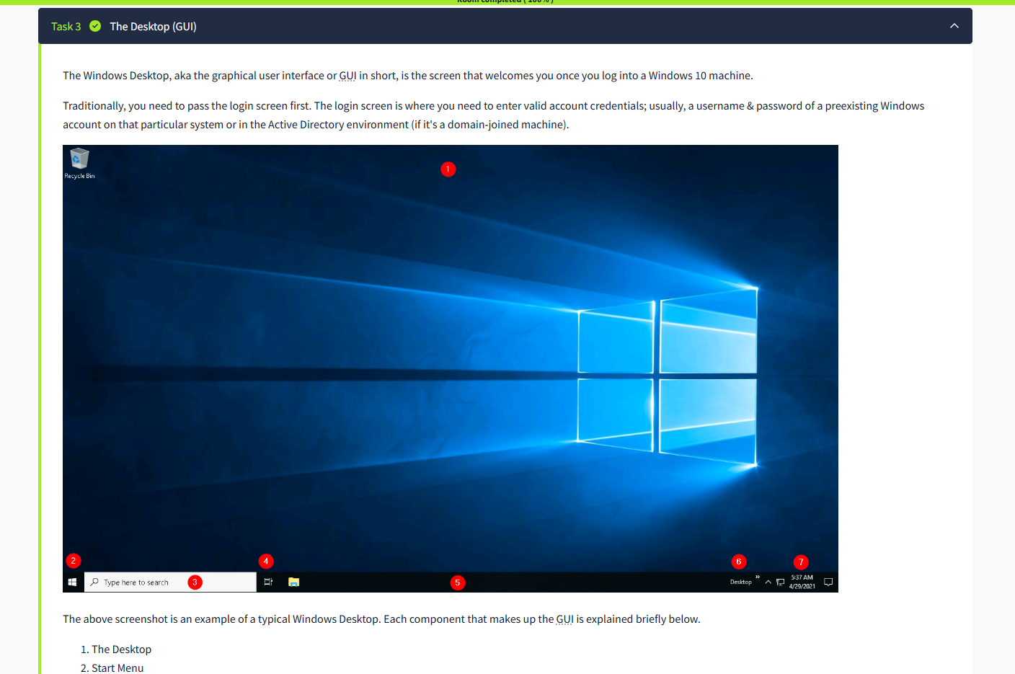

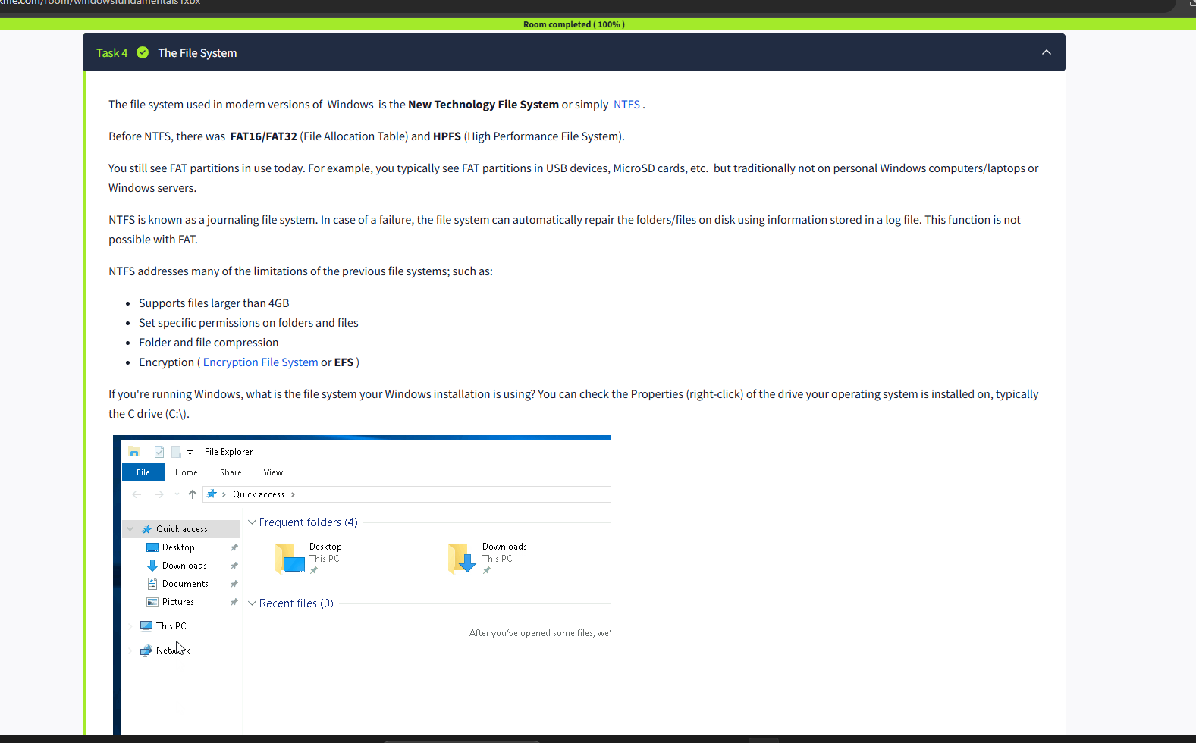

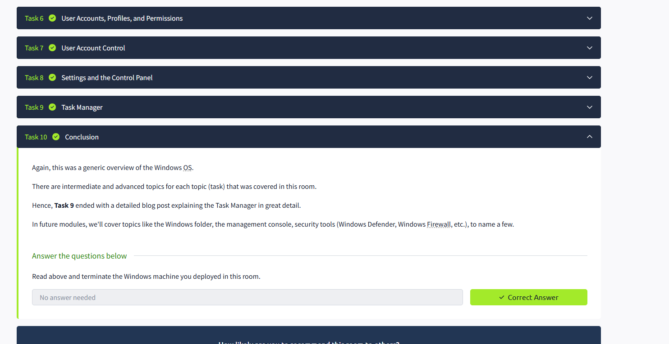

RESULT: The tasks in Windows fundamentals 1 has been completed successfully.

Experiment: BREAKING RSA SOMILA. SA

231901052

AIM: Hop in and break poorly implemented RSA using Fermat's factorization algorithm.

PROCEDURE:

• Task 1: Capture the flag

Task 1: Capture the flag

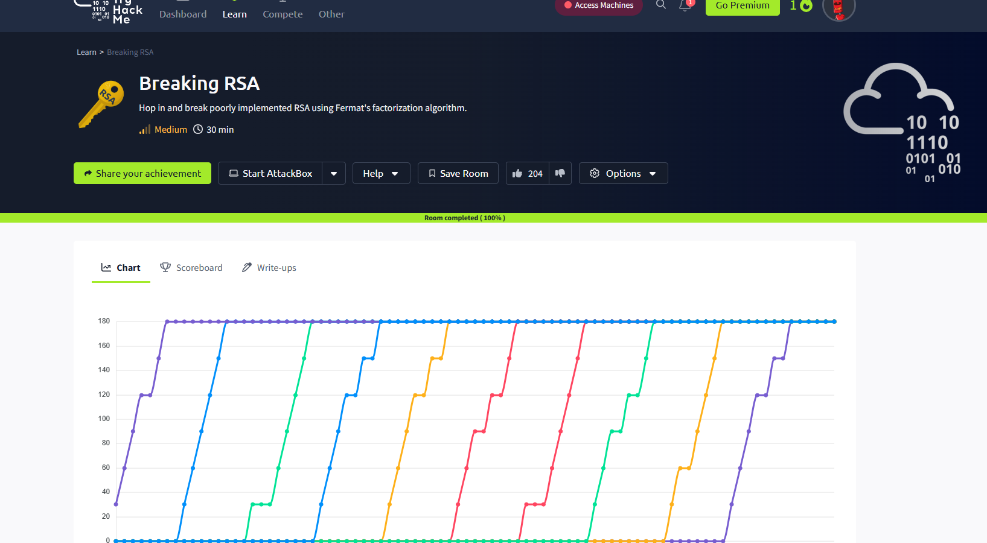

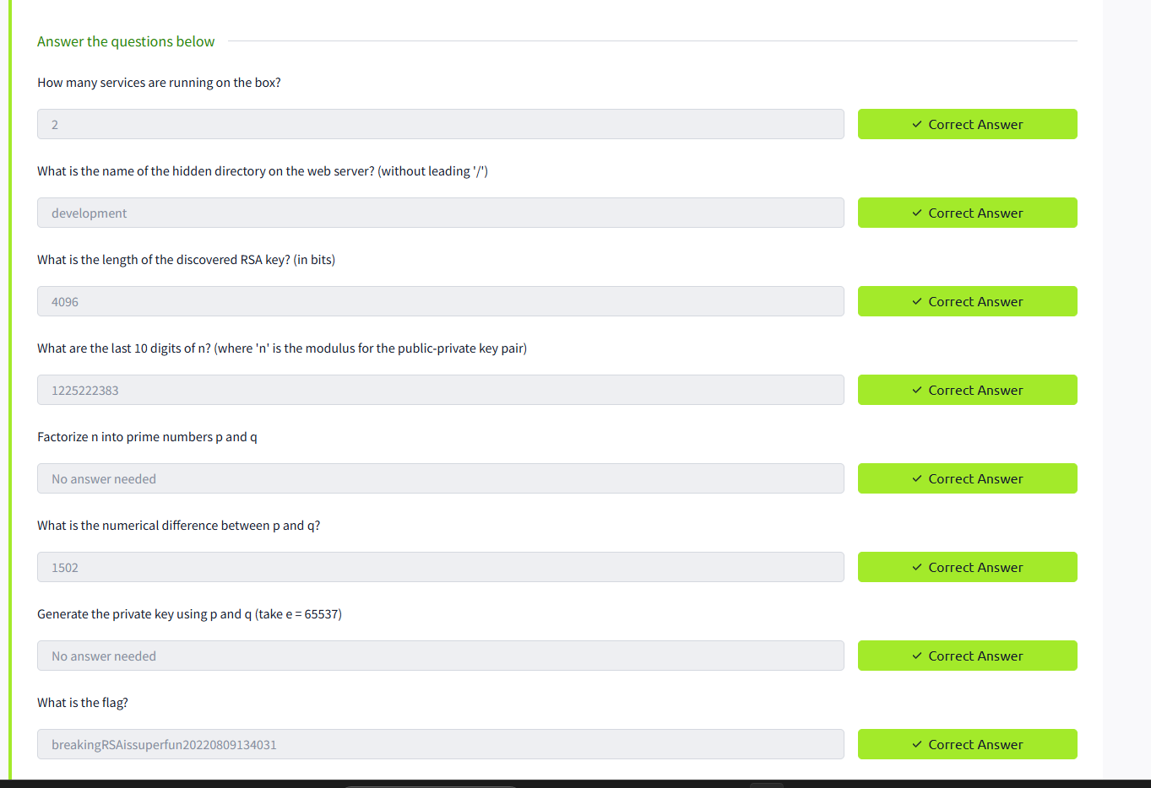

RESULT: Thus the Breaking RSA is successfully completed in tryhackme platform.

WINDOWS FUNDAMENTALS 2

SOMILA.SA

231901052

EX.NO:01 Date:12-02-2025

AIM: In part 2 of the Windows Fundamentals module, discover more about System Configuration, UAC Settings, Resource Monitoring, the Windows Registry and more.

PROCEDRE:

• Task 1 Introduction

• Task 2 System Configuration

• Task 3 Change UAC Settings

• Task 4 Computer Management

• Task 5 System Information

• Task 6 Resource Monitor

• Task 7 Command Prompt

• Task 8 Registry Editor

• Task 9 Conclusion TASKS:

Task 1:

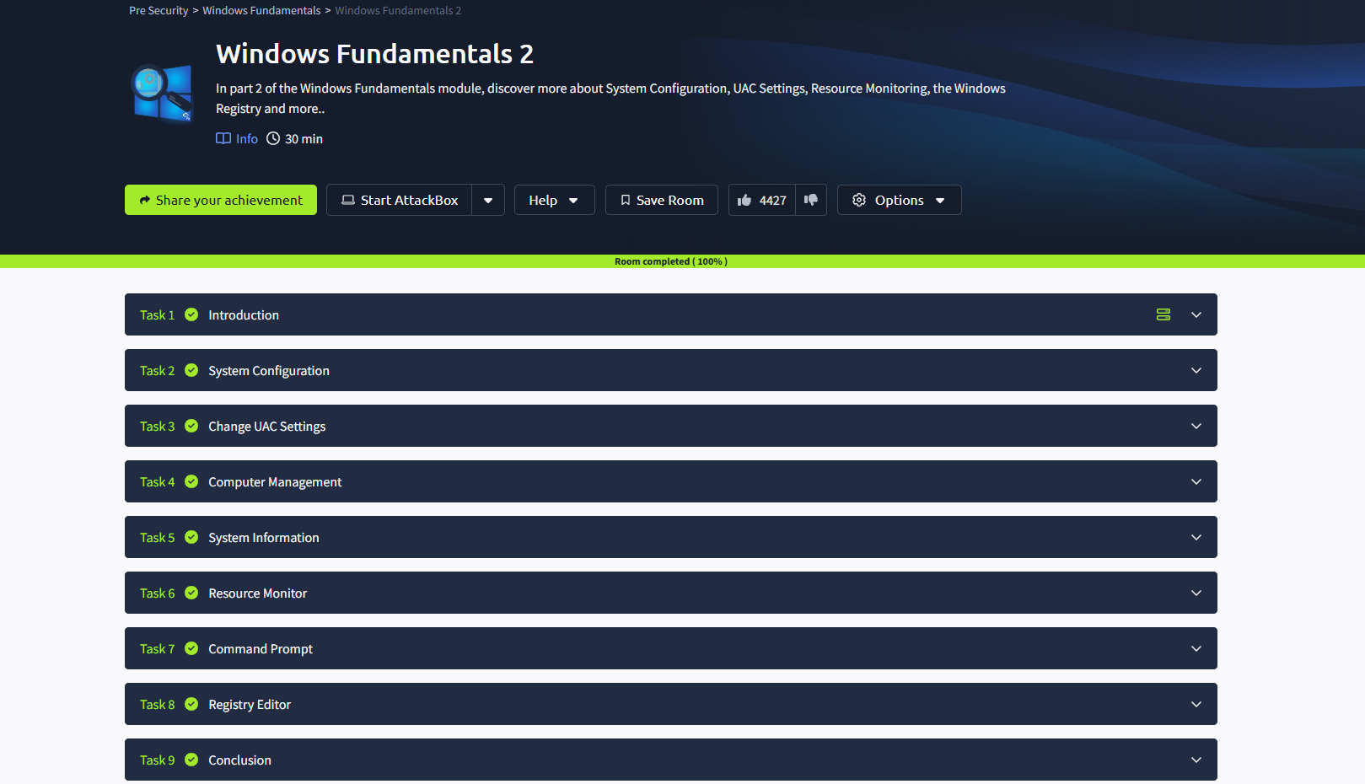

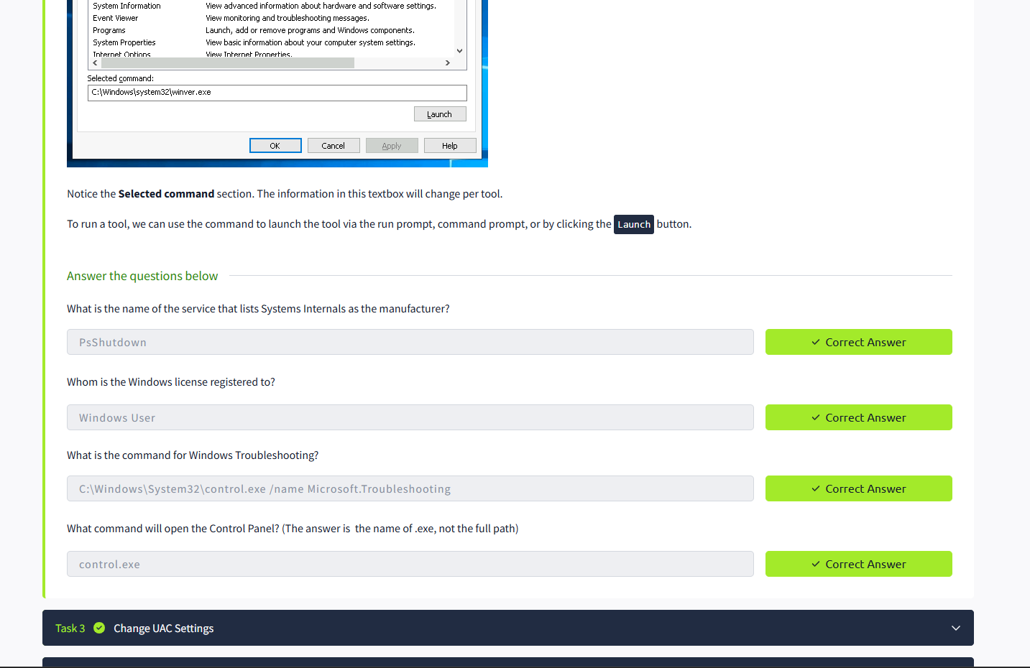

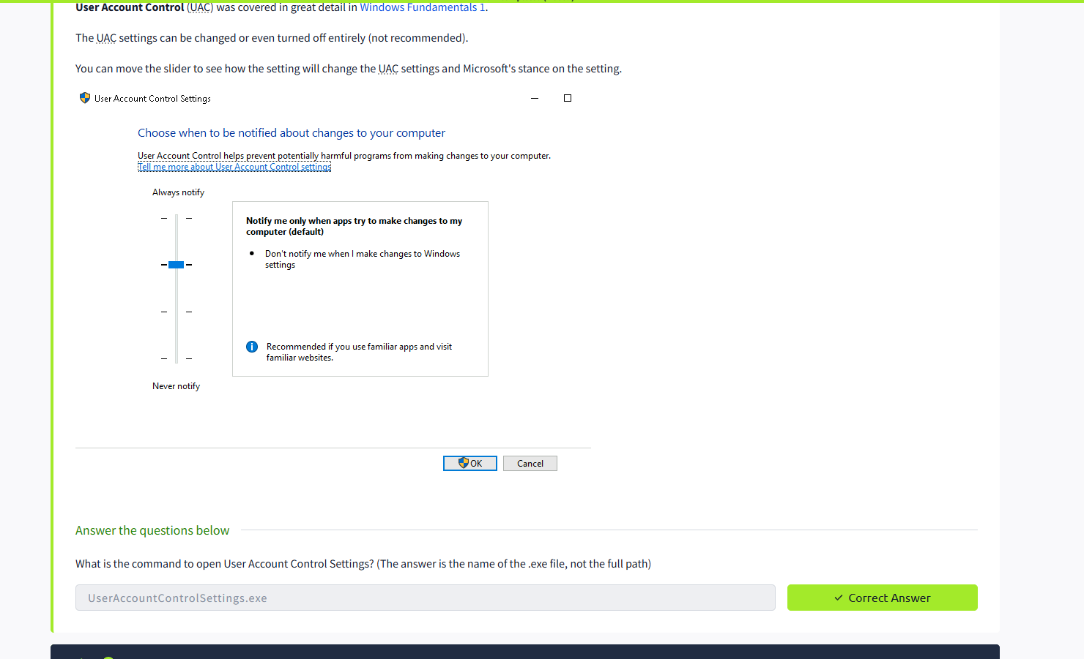

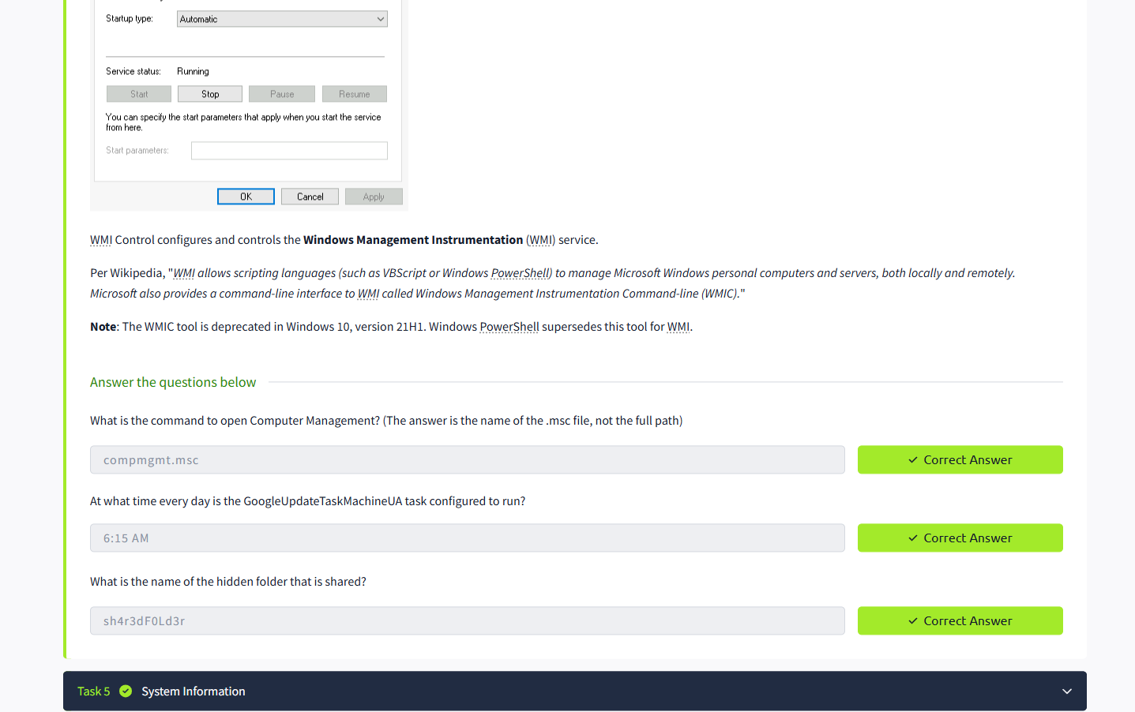

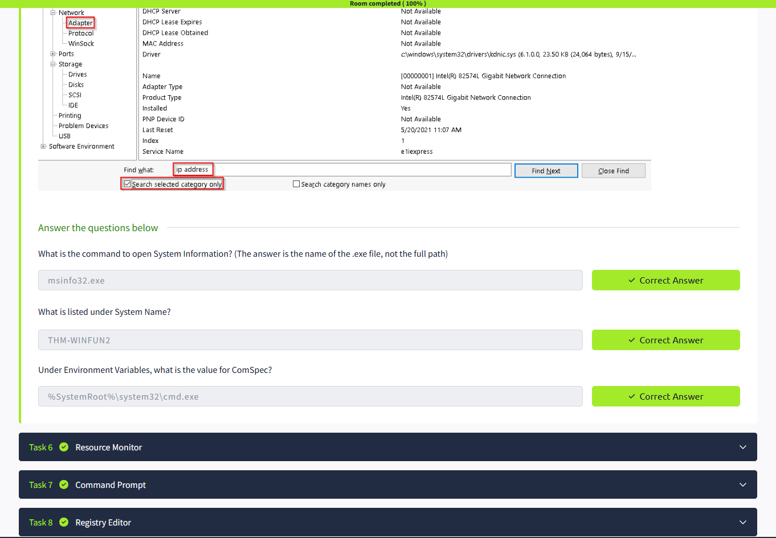

RESULT: Thus the windows fundamentals 2 successfully completed in tryhackme platform.

WINDOWS FUNDAMENTALS 3

SOMILA. SA

231901052

EX.NO:01 Date: 12-02-2025

AIM: In part 3 of the Windows Fundamentals module, learn about the built-in Microsoft tools that help keep the device secure, such as Windows Updates, Windows Security, BitLocker, and more. PROCEDURE:

• Task 1: Introduction

• Task 2: Windows Updates

• Task 3: Windows Security

• Task 4: Virus & threat protection

• Task 5: Firewall & network protection

• Task 6: App & browser control

• Task 7: Device security

• Task 8: BitLocker

• Task 9: Volume Shadow Copy Service

• Task 10: Conclusion TASKS:

Task 1:

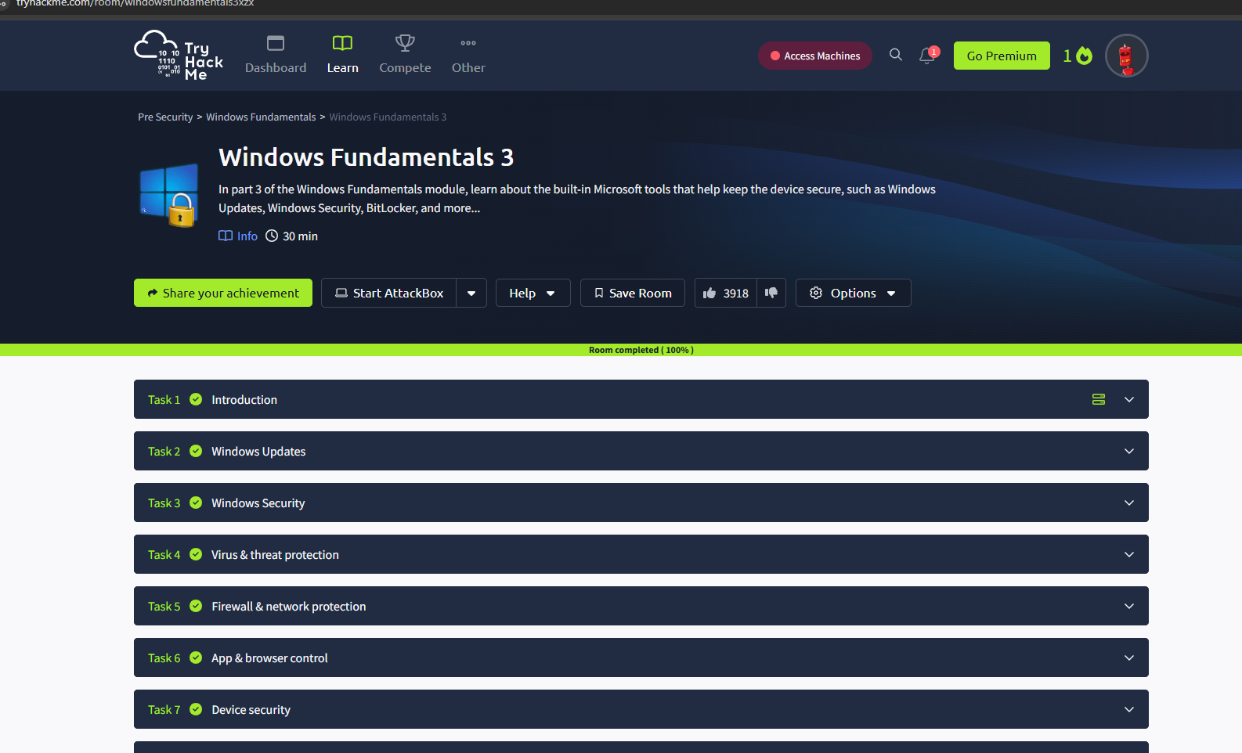

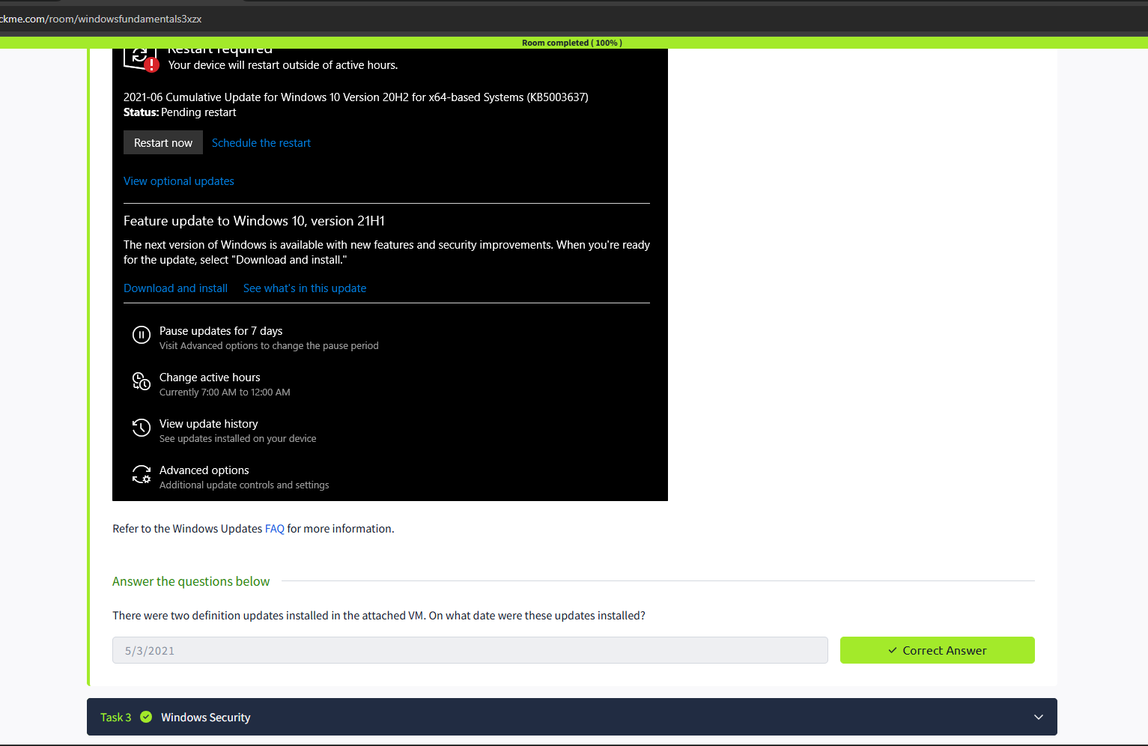

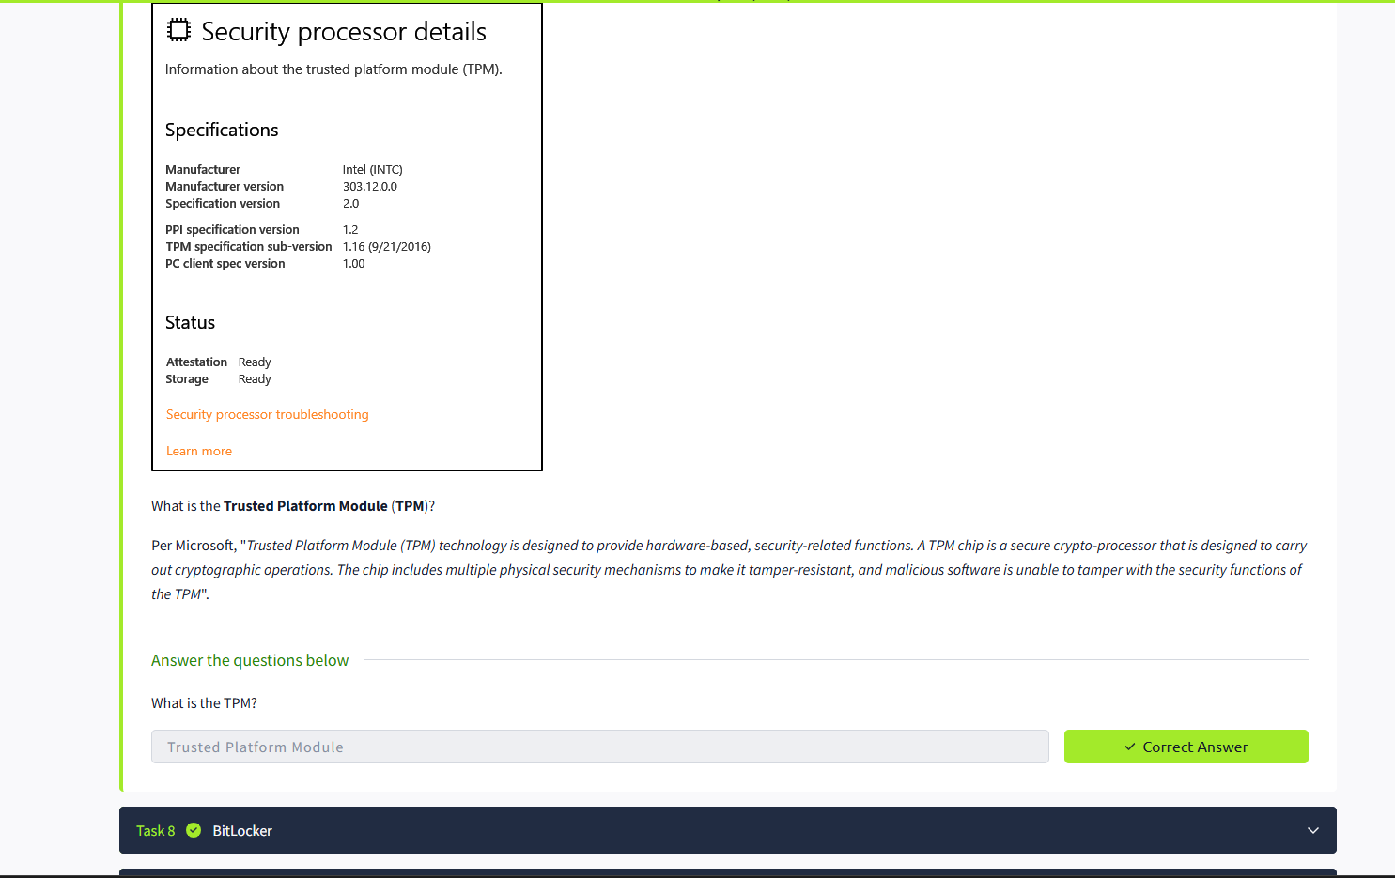

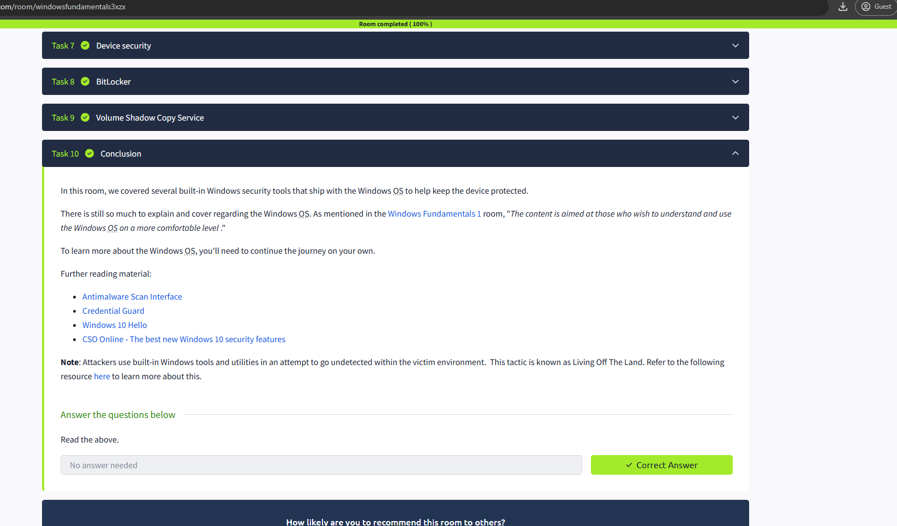

RESULT: Thus the windows fundamentals 3 successfully completed in tryhackme platform.

Security Principles

SOMILA.SA

231901052

EX-NO: 02 DATE:19:02:2025

AIM: Learn about the security triad and common security models and principles.

PROCEDURE:

Task 1: Introduction

Task 2: CIA

Task 3: DAD

Task 4: Fundamental Concepts of Security Models

Task 5: Defence-in-Depth

Task 6: ISO/IEC 19249

Task 7: Zero Trust versus Trust but Verify

Task 8: Threat versus Risk Task

9: Conclusion

Task 1:

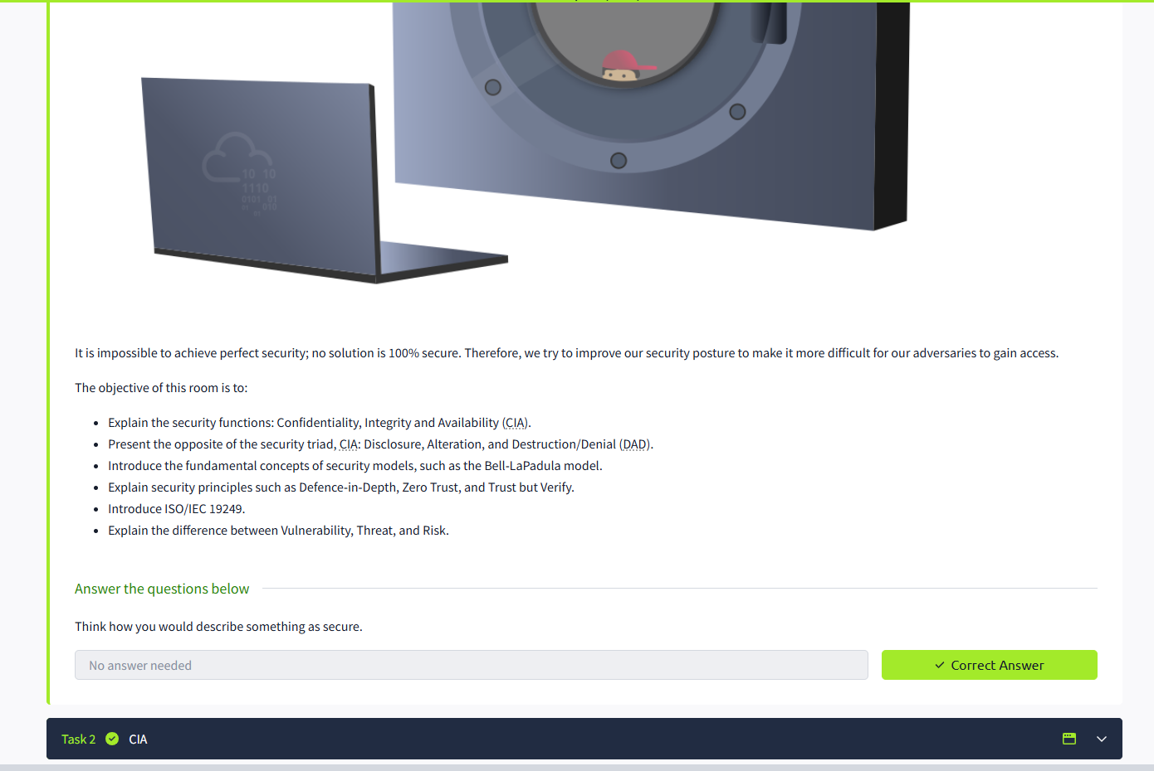

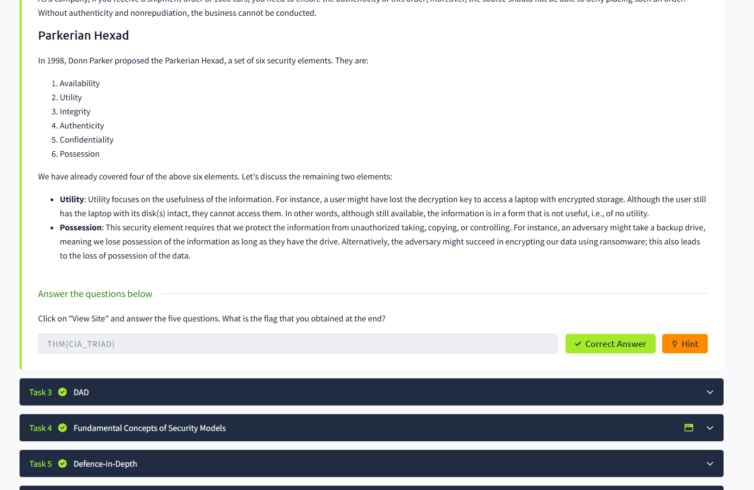

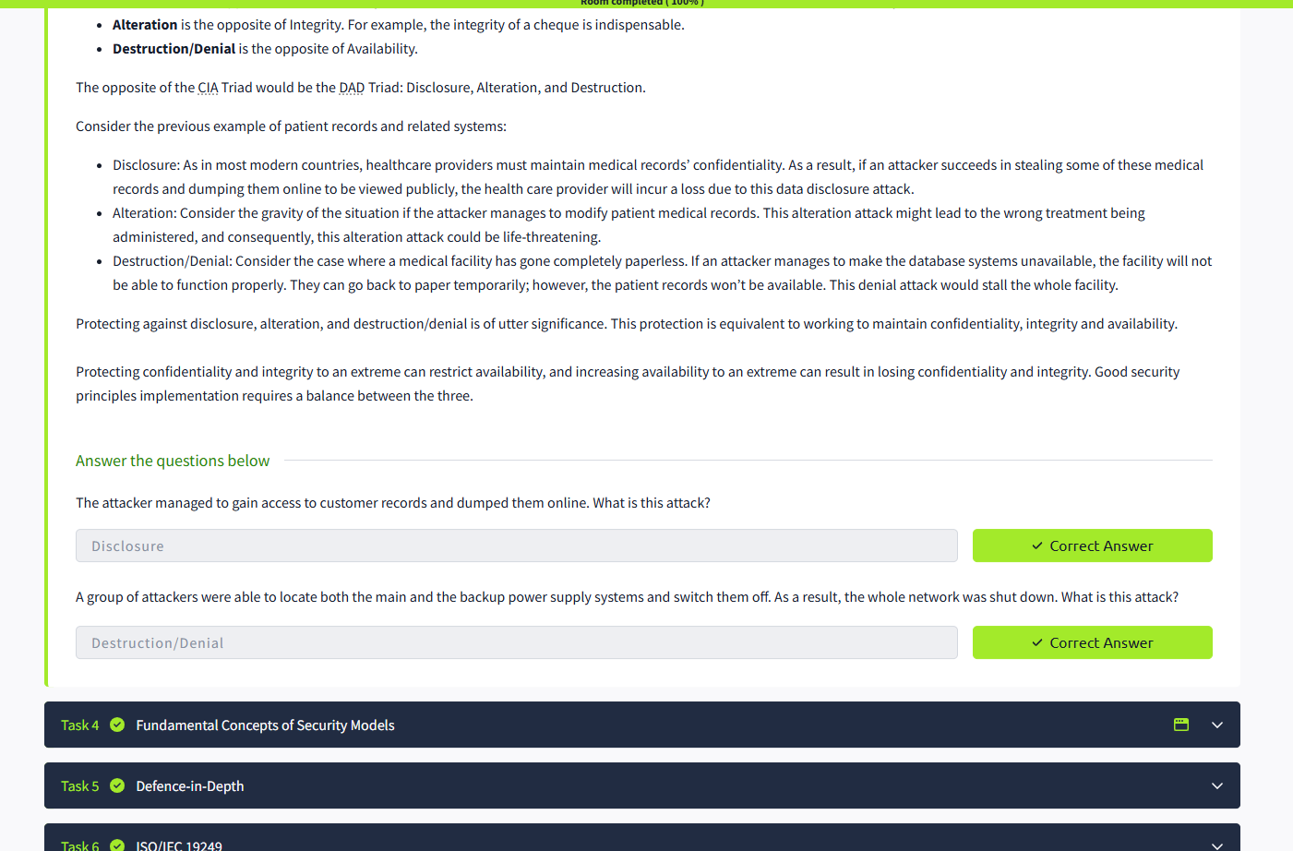

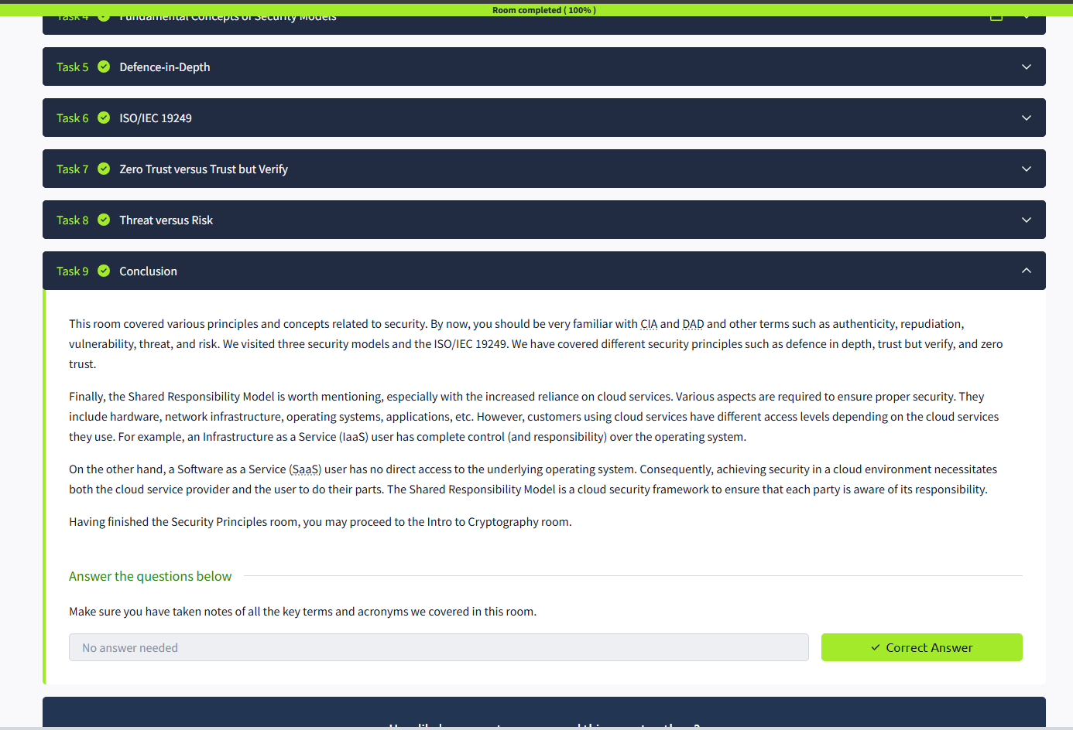

RESULT: Thus the security principles successfully completed in tryhackme platform.

Identity and Access Management

SOMILA.SA

231901052

EX-NO: 03 DATE: 19-02-2025

AIM: Learn about identification, authentication, authorisation, accounting, and identity management.

PROCEDURE:

• Task 1 Introduction

• Task 2 IAAA Model

• Task 3 Identification

• Task 4 Authentication

• Task 5 Authorisation and Access Control

• Task 6 Accountability and Logging

• Task 7 Identity Management

• Task 8 Attacks against Authentication

• Task 9 Access Control Models

• Task 10 Single Sign-On

• Task 11 Scenarios

• Task 12 Conclusion

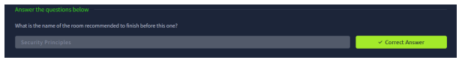

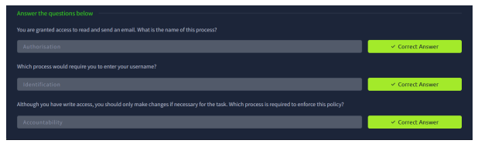

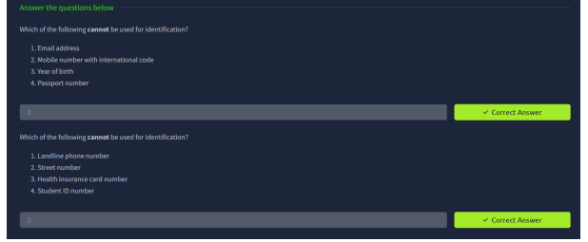

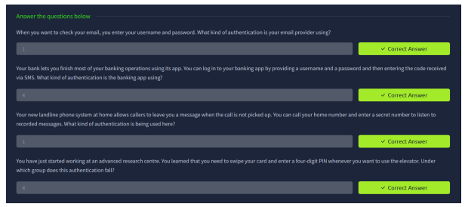

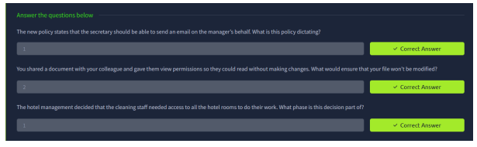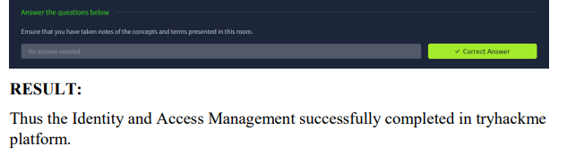

CARNAGE

SOMILA. SA

231901052

EX.NO:04 DATE: 19:02:2025

AIM: Apply your analytical skills to analyze the malicious network traffic using Wireshark. PROCEDURE:

• Task 1 Scenario

• Task 2 Traffic Analysis

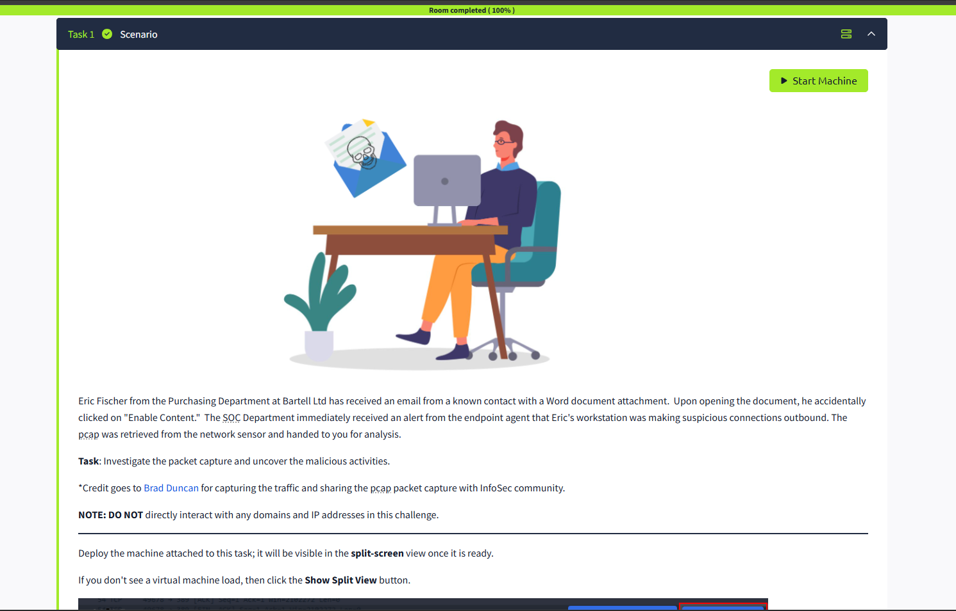

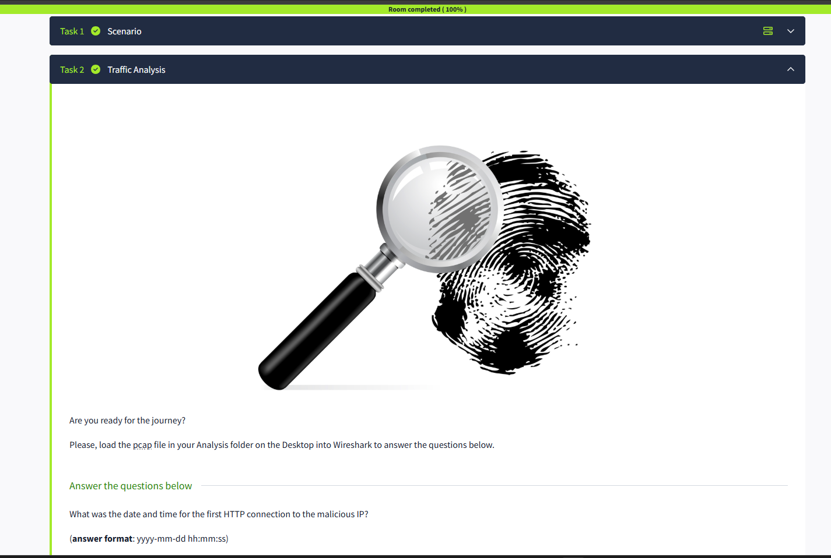

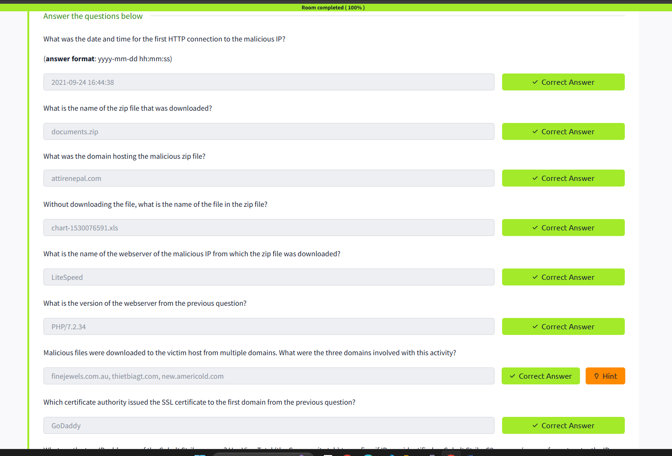

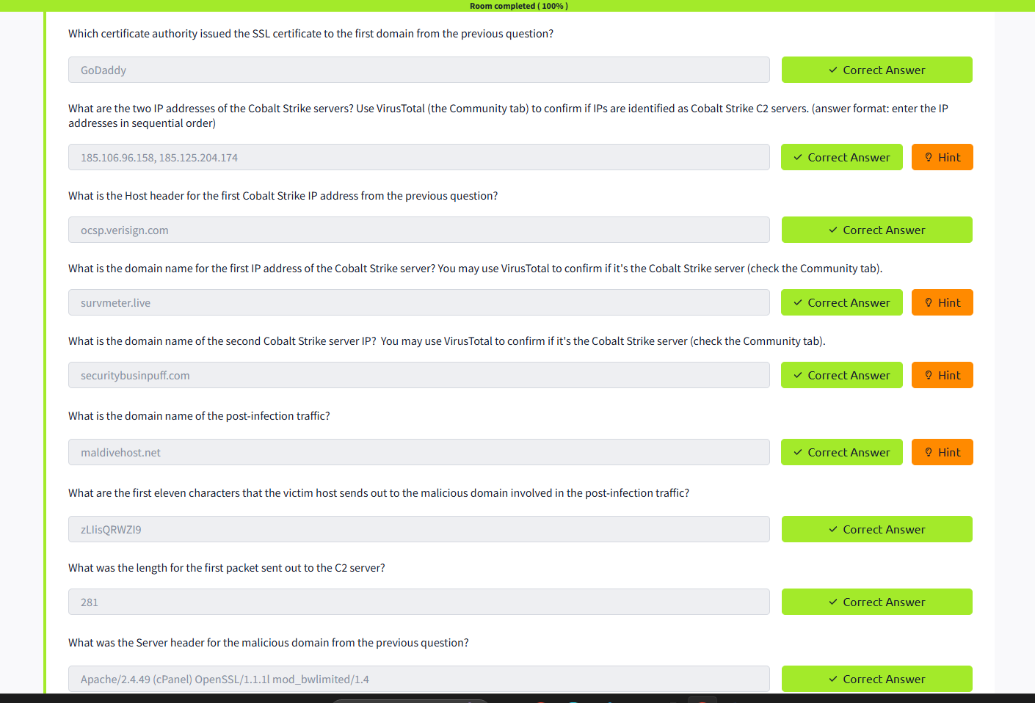

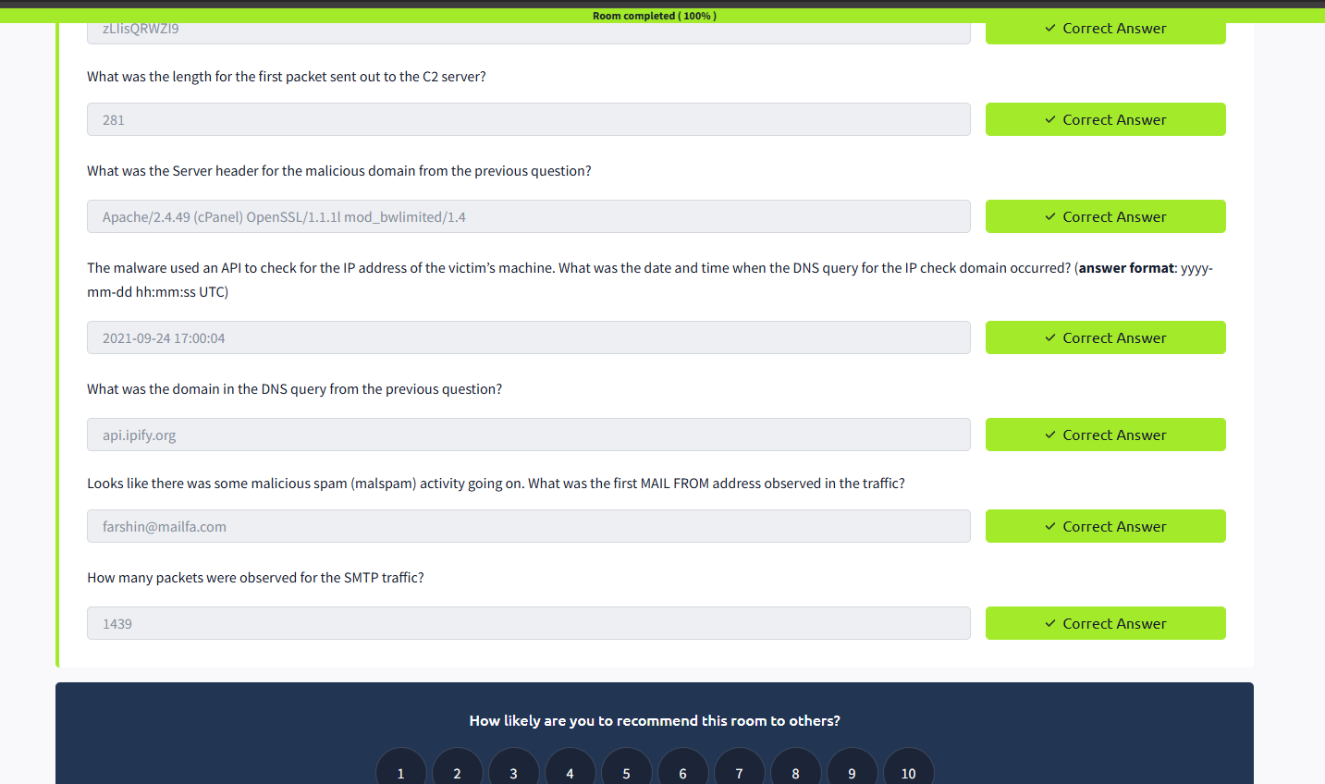

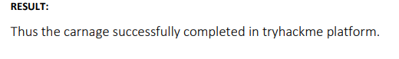

Sudo Buffer Overflow

SOMILA.SA

231901052

EX.NO:05 DATE: 19-03-2025

AIM: A tutorial room exploring CVE-2019-18634 in the Unix Sudo Program. Room Two in the SudoVulns Series.

PROCEDURE:

• Task 1 Deploy!

• Task 2 Buffer Overflow

